**NAME: AKANSHA SHETTY USN: 22BTRAD002 COURSE: AI/DE SECTION: A**

**DATE: 13/09/2023**

**GITHUB:** https://github.com/Akansha-S1/SCALA_PROGRAMMING

**Problem statement : 11: Write a Scala program that creates a class called Person with properties like name, age and country. Implement methods to get and set properties.**

**(Object oriented programming)**

**TEST CASE 1:** Use given data:

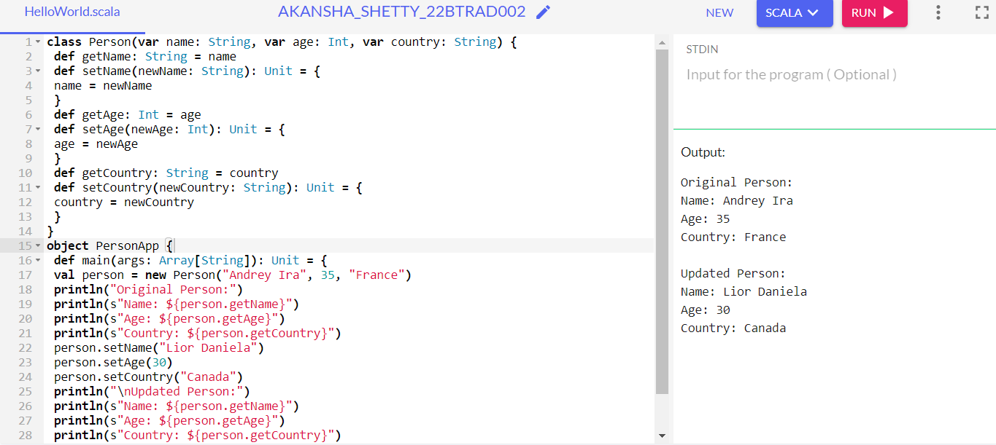

cont-

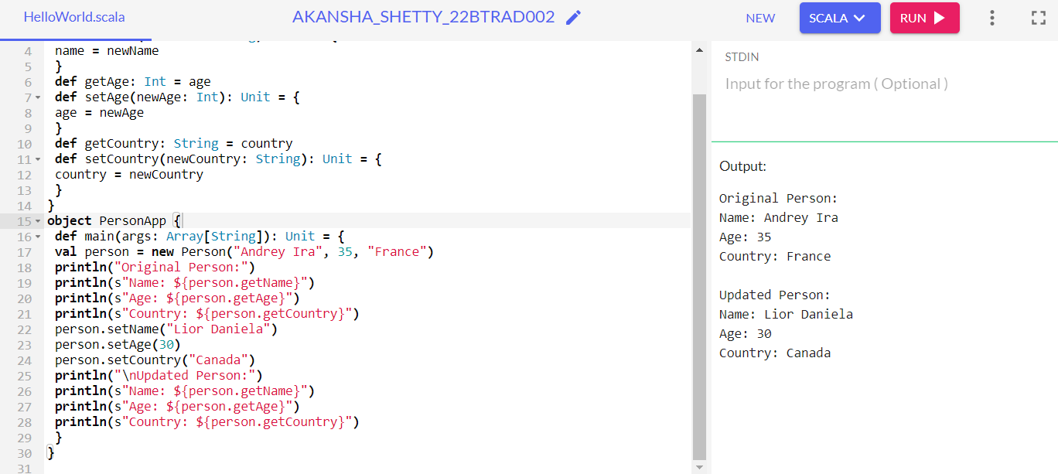

**TEST CASE 2:** Update with your own data:

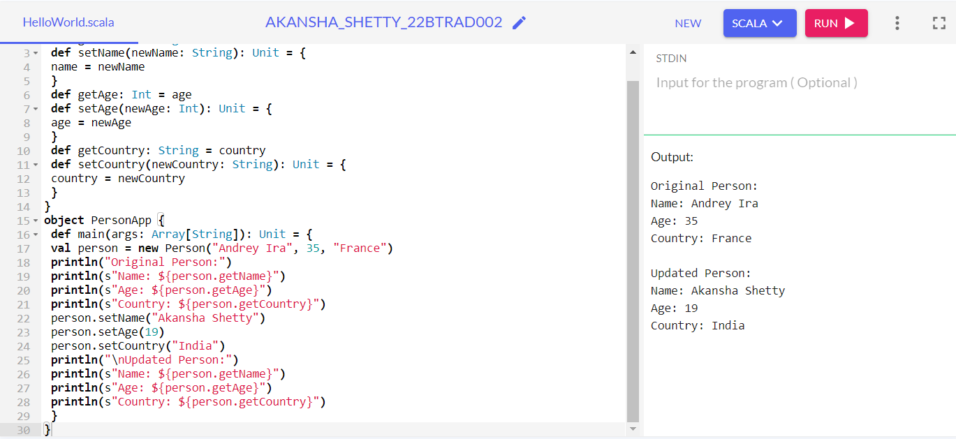

**Modifying the code myself to add another attribute: Hobby:**

**Code:**

class Person(var name: String, var age: Int, var country: String, var hobby: String) {

def getName: String = name

def setName(newName: String): Unit = {

name = newName

}

def getAge: Int = age

def setAge(newAge: Int): Unit = {

age = newAge

}

def getCountry: String = country

def setCountry(newCountry: String): Unit = {

country = newCountry

}

def getHobby: String = hobby

def setHobby(newHobby: String): Unit = {

hobby = newHobby

}

}

object PersonApp {

def main(args: Array[String]): Unit = {

val person = new Person("Andrey Ira", 35, "France", "Photography")

println("Original Person:")

println(s"Name: ${person.getName}")

println(s"Age: ${person.getAge}")

println(s"Country: ${person.getCountry}")

println(s"Hobby: ${person.getHobby}")

person.setName("Akansha")

person.setAge(19)

person.setCountry("India")

person.setHobby("Tennis")

println("\nUpdated Person:")

println(s"Name: ${person.getName}")

println(s"Age: ${person.getAge}")

println(s"Country: ${person.getCountry}")

println(s"Hobby: ${person.getHobby}")

}

}

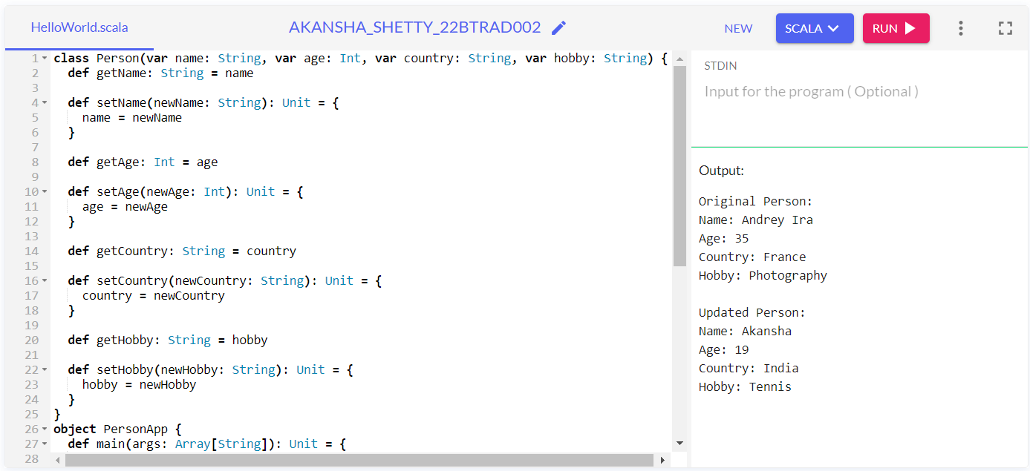

**MODIFYING THE CODE TO MAKE IT BETTER FROM A USER’S PERSPECTIVE:**

**OUTPUT:**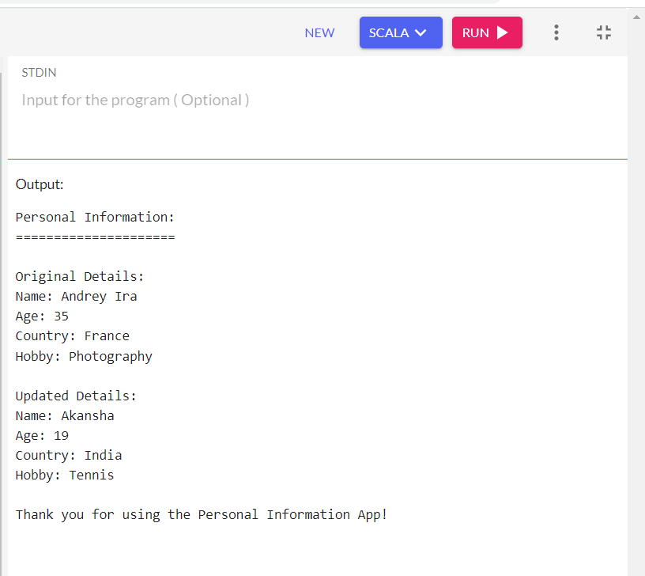

**WHAT ARE THE CHANGES:**

* **Added a title "Personal Information" to let the user know of what the table consists**
* **Added separation lines "=====================" to visually separate sections.**
* **Renamed "Original Person:" to "Original Details:" and "Updated Person:" to "Updated Details:" for clarity.**
* **Included a "Thank you" message at the end to indicate the end of the program.**

**CODE:**

class Person(var name: String, var age: Int, var country: String, var hobby: String) {

def getName: String = name

def setName(newName: String): Unit = {

name = newName

}

def getAge: Int = age

def setAge(newAge: Int): Unit = {

age = newAge

}

def getCountry: String = country

def setCountry(newCountry: String): Unit = {

country = newCountry

}

def getHobby: String = hobby

def setHobby(newHobby: String): Unit = {

hobby = newHobby

}

}

object PersonApp {

def main(args: Array[String]): Unit = {

val person = new Person("Andrey Ira", 35, "France", "Photography")

println("Personal Information:")

println("=====================")

println("\nOriginal Details:")

println(s"Name: ${person.getName}")

println(s"Age: ${person.getAge}")

println(s"Country: ${person.getCountry}")

println(s"Hobby: ${person.getHobby}")

person.setName("Akansha")

person.setAge(19)

person.setCountry("India")

person.setHobby("Tennis")

println("\nUpdated Details:")

println(s"Name: ${person.getName}")

println(s"Age: ${person.getAge}")

println(s"Country: ${person.getCountry}")

println(s"Hobby: ${person.getHobby}")

println("\nThank you for using the Personal Information App!")

}

}

**Explanation:**

* We are demonstrating how to use the getter and setter method
* First create a ‘person’ class with initial values.
* The class has attributes such as ‘name’, ‘age’ and ‘country’.
* Getter methods (getName, getAge, getCountry) are used to retrieve the current values of the attributes.
* Setter methods (setName, setAge, setCountry) have been used to update the original values.
* The PersonApp object contains the main method, which serves as the entry point for the application.
* Then an instance is created with initial values ("Andrey Ira" for name, 35 for age, and "France" for country).
* The program then prints the original values of the Person instance using the getter methods.
* Next, the setter methods are used to update the Person's attributes to "Lior Daniela" for name, 30 for age, and "Canada" for country.
* Finally, the updated values of the Person instance are printed.